Evolution of the Atomic Model
Concepts to Cover:
- Evolution of the Atomic Theory Reading
- Atomic Theory Important Scientists
- Mini-Project: Evolution of the Atomic Theory Foldable Instructions

Background Knowledge:
The history of the atom goes back for centuries. Around 440 B.C., the Greek philosopher Democritus first theorized the existance of a tiny "uncuttable" particle that would make up everything in the world around him. Each of these particles would be small, solid spheres, that could not be broken down any further. Each would possess unique features that affected the properties of that particle. For example, he thought that if a substance had a foul odor, than the particle must be spiny or prickly. From the Greek word for "uncuttable" (atomos), we derive the current word "atom"!
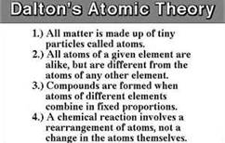
In 1802-1803, the British schoolteacher and meterologist John Dalton, revisited Democritus's ideas

of
the atom and developed his "Atomic Theory" that scientists still recognize today. In it, he reaffirmed Democritus's idea that matter is made up of tiny particles that he called "atoms," and that atoms of one element are the same as all of the other atoms of that element, while atoms of different
atoms were different. He then elaborated to say that a "compound" forms when atoms of different elements combine together, and a chemical reaction occurs when these atoms are rearranged, but the atoms are not affected themselves. Dalton called his atom, the
"Billiard Ball" model after its likeness to a billiard (pool) ball.

Around 1897, another British scientist named J.J. Thomson, made a huge contribution towards understanding what made up the atom. Using a cathode ray gun, he passed an electric current through magnetized plates, and found that by positively or negatively charging the plates, he could
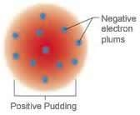
change the direction of the electrical current. Because the charges of the plate dictated the direction that the current would move, he then understood that the atom had to be made up of positive and negative charges. From this experiment, we get the electron, a negatively charged particle within the atom. This experiment led Thomson to the idea that the atom was a sphere filled with a positively charged fluid, and negatively charged particles (electrons) were floating within it. Because this idea reminded him of plums suspended in bread, he called his model, the "Plum Pudding" model.
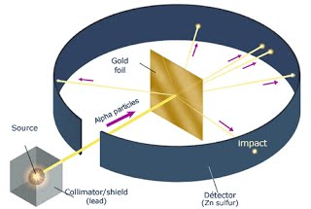
The next big discovery that changed the view of the atom, came between 1909-1911. New Zealand physicist Ernest Rutherford, with the help of

Hans Geiger (yes, of the radiation detecting device, the "Geiger counter!") and Ernest Marsden, conducted the famous "Gold Foil Experiment." In
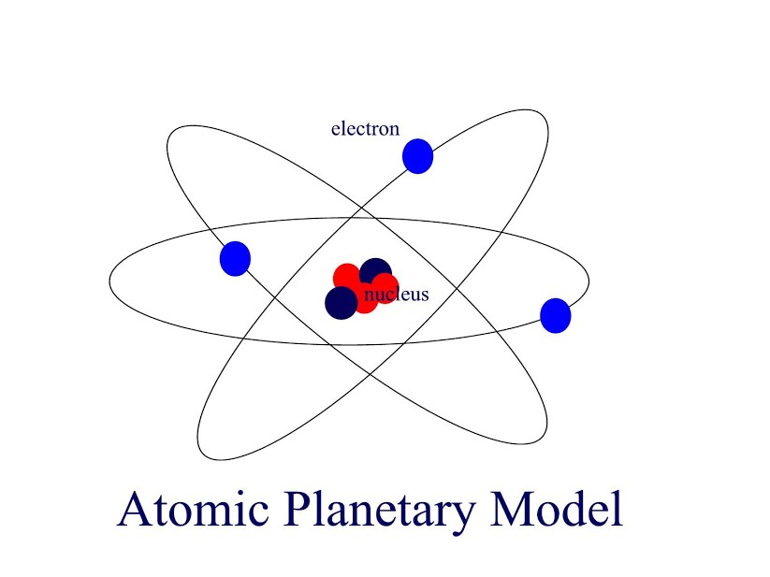
it, alpha particles were directed through a thin slit in a lead screen towards a thin gold foil, only 100 atoms thick. They predicted that if the positive and negative charges were evenly spread throughout the atom, than the atoms wouldn't have enough energy to deflect the heavy alpha particles. Most of the particles passed through the foil as expected, however some of the particles were deflected off of the foil, and some even bounced backwards. This surprised the scientists, and led them to conclude:
- Since most of the alpha particles went straight through the foil, that atoms have to be made up of mostly empty space.
- Since the positively charged alpha particles were deflected at such extreme angles, there had to be something positive causing the deflection.
- This dense, positively

- charged region in the center of the atom is now known as the nucleus.
- Since there were so few alpha particles that were deflected, they believed that the nucleus had to be small compared to the total size of the atom.
This new vision of the atom began to take on a shape similar to the planet Saturn, with a dense region in the center, orbited by electrons like the rings around the planet. For this reason, his model then became known as the "Planetary Model."

In 1913, one of Ernest Rutherford's students, a Danish physicist by the name of Niels Bohr, proposed

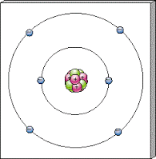
changes to the Planetary Model. To try and explain why the electrons orbiting around the atom do not lose energy and spiral inwards towards the nucleus, he proposed that the electrons orbit in distinct orbits, but electrons could jump between these orbitals by either gaining energy (moving to farther away electron shells), or by losing energy (falling to electron shells closer to the nucleus). The energy would be either absorbed or emitted in
the form of photons, or bundles of energy that are the basic units of light. These photons can be detected through the use of a spectroscope, and are used to identify atoms of different elements both here on Earth, and in stars and galaxies throughout the universe. Bohr also proposed that the size of the atom was much smaller than previously thought, and explained that the electrons orbited the nucleus in concentric circles. The inner shells, because of their size and proximity to the nucleus, could hold fewer electrons in their orbits than the outer shells. His model became widely known as the "Bohr Model."

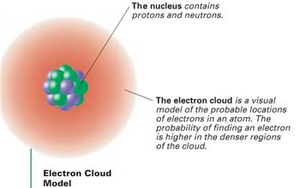
The Bohr Model was efficient at explaining the properties of the element Hydrogen, however, it failed to explain the properties for elements more complex than that. Because of this, other scientists began working to understand what Bohr could not explain. Around 1924, Louis de Broglie, a French physicist, introduced his theory of electron waves as the wave/particle duality theory of matter. Basing his ideas on the work of Max Planck and Albert Einstein, he suggested that "any moving particle or object had an associated wave" (http://www.princeton.edu/~achaney/tmve/wiki100k/docs/Louis_de_Broglie.html) through which the particle could be transported. From

this, we understand that particles can sometimes behave as a particle, and could othertimes behave as a wave. Around the same time, Erwin Schrödinger developed a mathematical formula to explain de Broglie's work. From this new understanding, we came to view the atom not as a nucleus surrounded by electrons moving in perfectly circular orbits, but that as electrons moving in waves around the nucleus. The orbits would then be different sizes depending on the electrons' wavelengths, as a direct result of the momentum of the electron. Instead of perfectly circular orbits, the electrons would be found in clouds of space around the nucleus. In addition, it is impossible to know the speed and the exact location of the electon within this cloud, but we can calculate the probability of finding it within the given space. Their model is known as the "Electron Cloud Model," or the "Quantum Mechanical Model."

*NOTE: Many more scientists have contributed to the evolution of the atom than what is listed here. For a more comprehensive list, feel free to check out the following link: http://atomictimeline.net/index.php

Atomic Theory Timeline Foldable

Using your research notes to aid you, construct a timeline foldable of the most important advancements in the atomic theory, including who was responsible for the discovery, and what experiments they conducted, or the observations they made that lead to their groundbreaking conclusion. The scientists to include in your timeline are listed below, however, on your timeline they should be listed in the order of their discovery. Good luck!

Neils Bohr Ernest Rutherford Democritus
John Dalton J.J. Thompson

Each panel of your foldable should include all of the following information:

- Scientist
- Year (in order from earliest to most recent)
- Name of model/theory
- Diagram of model
- Brief description of model
- Brief explanation of experiments leading to discovery

